

**project Development Phase**



**Model Performance Test**

|  |  |
| --- | --- |
| **Date** | **31 october 2023** |
| **Team ID** | **NM2023TMID03779** |
| **Project Name** | **Project – Agriculture Docs Chain** |
| **Maximum Marks** | **10 Marks** |



**Model Performance Testing:**

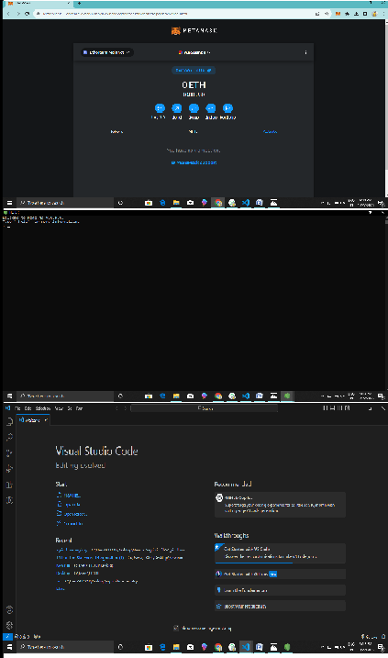Project team shall fill the following information when working for blockchain.

|  |  |  |  |
| --- | --- | --- | --- |
| **S.No.** | **Parameter** | **Values** | **Screenshot** |
| **1.** | **Information gathering** | **Setup all the Prerequisite: 1.node.js**  **2.vs code 3.metamask** | |

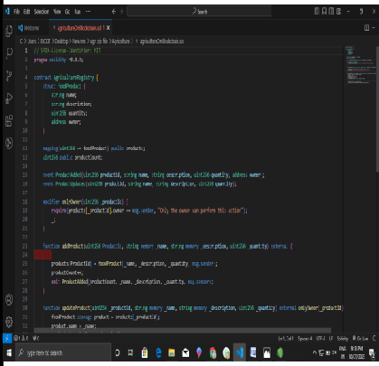

|  |  |  |  |
| --- | --- | --- | --- |
| **2.** | **Extract the zip files** | **Open to vs code** | |
| **3.** | **Remix Ide platform explorting** | **Deploy the smart contract code**  **Deploy and run the transaction. By selecting the environment - inject the MetaMask.** |  |

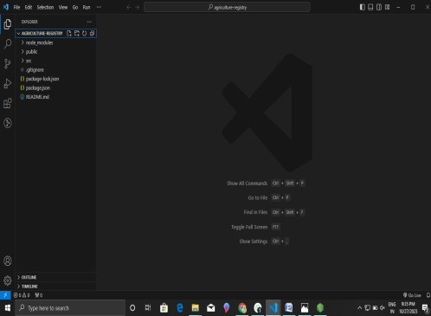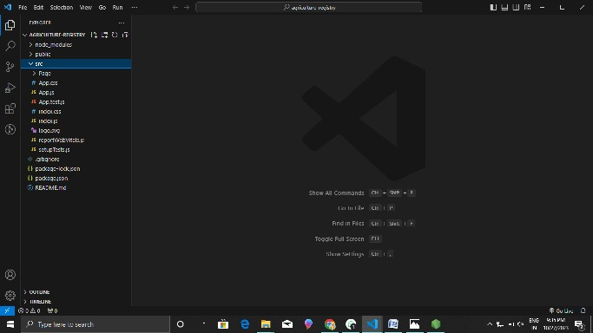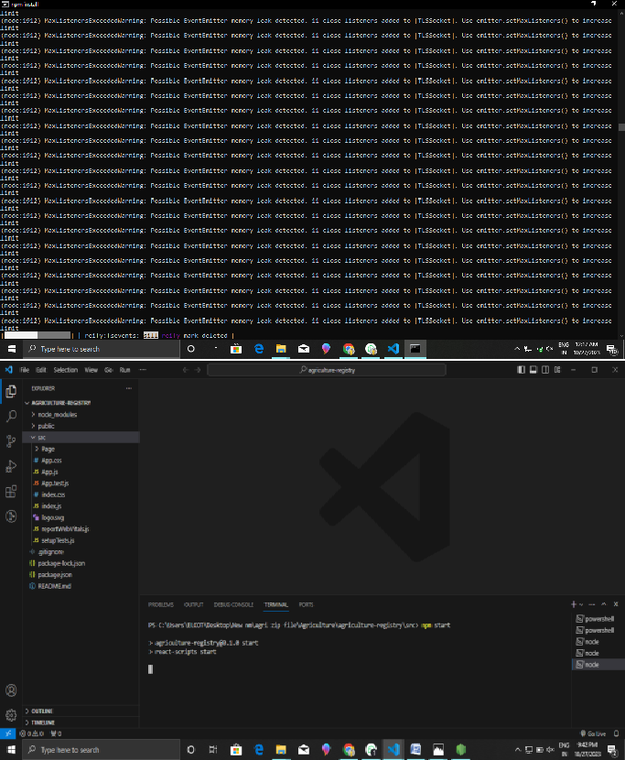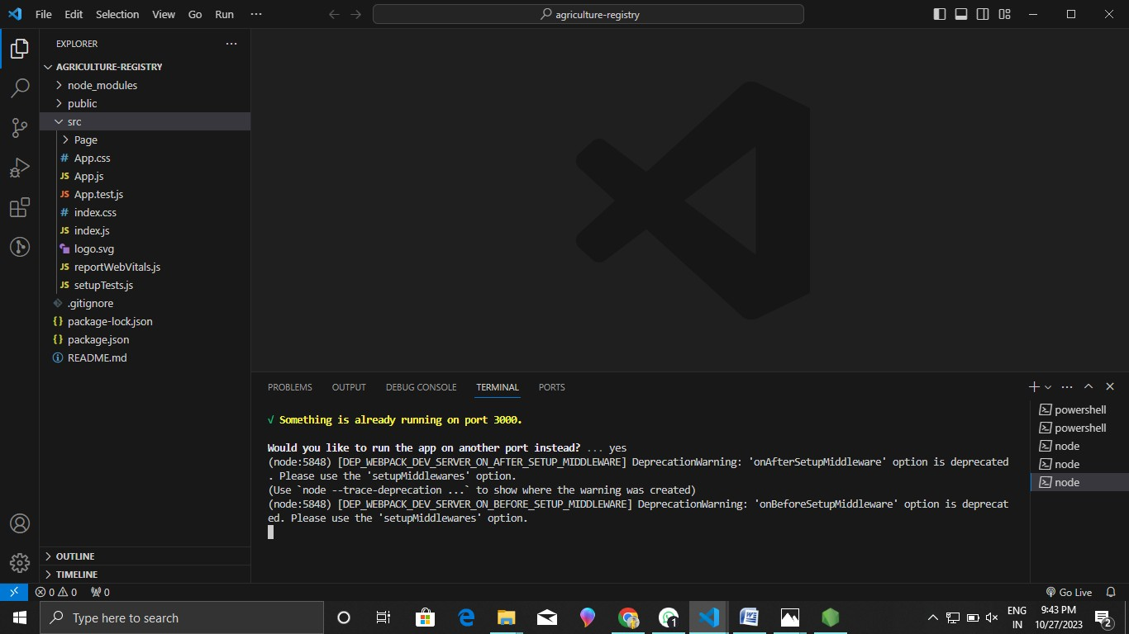

|  |  |  |  |
| --- | --- | --- | --- |
| **4.** | **Open file explorer** | **Open the extracted file and click on the folder.**  **Open src, and search for utiles.**  **Open cmd enter commands 1.npm install**  **2. npm bootstrap 3.npm start** |  |

|  |  |  |  |
| --- | --- | --- | --- |
| **5.** | **{LOCALHOST IP ADDRESS** | **copy the address and open it to chrome so you can see the front end of your project.** | **‘** |